SIGNAL PROCESSING

LAB – 7 REPORT

Abhinav Marri

2021112015

**Question – 1**

a) We sample the signal sin(2pif0t) with f0 = 10 Hz with a sampling frequency of 5KHz.

b) Plotting the sampled signal, quantized signal and the error obtained with parameters a = 1 and B = 4.

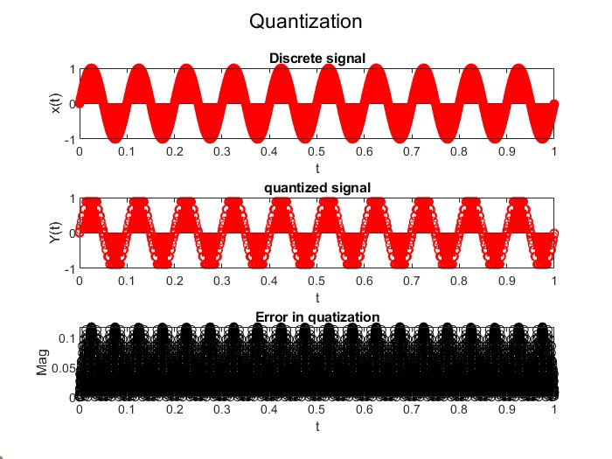

c) The error is also plotted in the figure above.

d) Plotting histograms of error with 15 bins for two different values of B.

* B = 4.

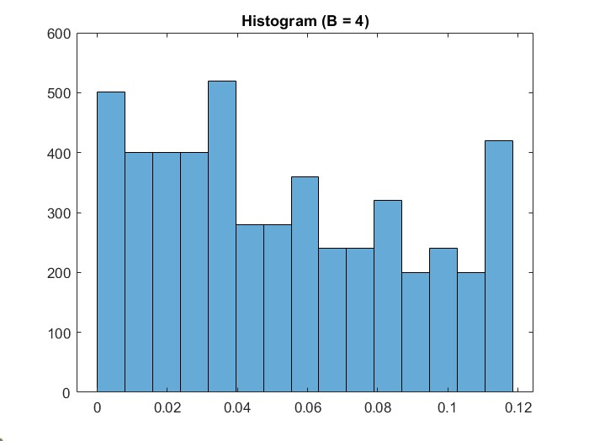

* B = 3.

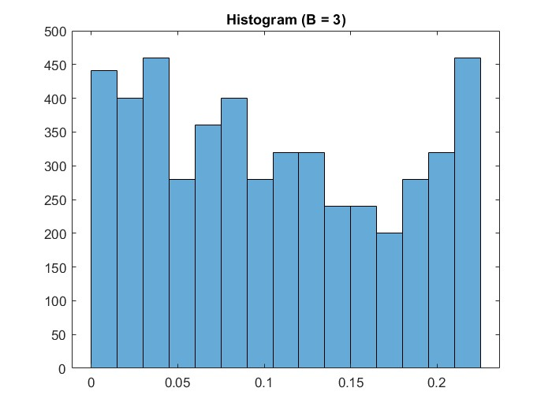

* A higher value of B, that is B = 4 gives us lesser error compared to B = 3.

e) Performing quantization for B = 1to B = 8 and plotting the maximum absolute quantization error with respect to B.

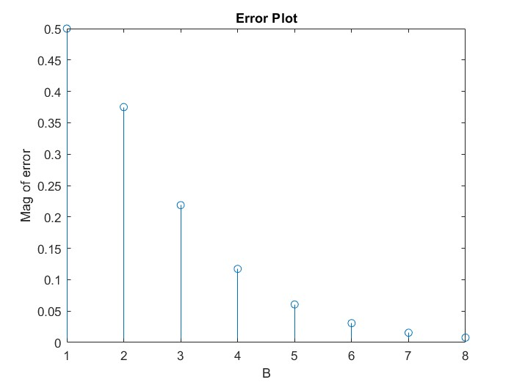

We can observe that as the value of B increases the maximum absolute quantization error decreases and almost goes to 0 with B = 8. As B represents the number of bits that are used to perform quantization, the levels of quantization possible increases. With this we can get more and more accurate quantization results.

f) *SQNR stand for signal to quantization noise ratio. The SQNR reflects the relationship between the maximum nominal signal strength and the quantization error (also known as quantization noise) introduced in the analog-to-digital conversion.*

SQNR is defined by :

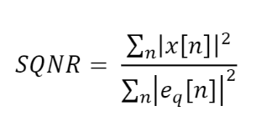

The plot of SQNR observed :

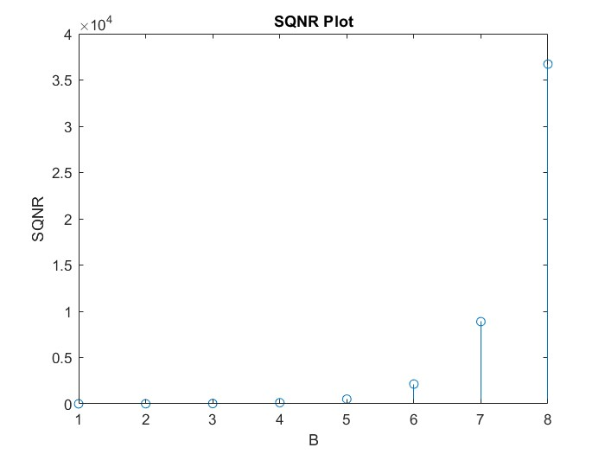

We can observe that with increase in the number of bits used (B), we can observe a higher and better SQNR. This is directly the result of lesser error at higher number of quantization levels.

G)

Difference between uniform and nonuniform quantization is that,  in the uniform quantization, some amount of quantization error can happen, but nonuniform quantization reduces the quantization error.

The lesser quantization error in non-uniform quantization provides for a better SQNR. This is desired and thus, it is better to use a non-uniform quantizer.

**Question 2**

We have used the WAV_1.wav file provided in the previous lab. The script ‘q2.m’ quantizes the signal using 3 bits and plays the signal after quantization. The quantized signal sounds worse as compared to that of the original, this is because some of the amplitudes are reduced to intermediate values of the buckets and the sound loses quality. This also happens as quantization introduces error.

When the value of B is changed from 1 to 8. We can observe that the amount of error decreases as the number of bits used increases and also the quality of the sound signal improves.

The frequency when quantized drops, with increased B, that is more accurate quantization the frequency gets closer to that of the original signal.